**Digital Image Processing**

**Title:** **Connected Component Labeling**

**Tools Used: MATLAB**

**Procedure:** Open MATLAB and perform the following tasks

**Task 1:**

Design a MATLAB GUI, as shown below, to implement following operations:

1. Load Image: read image *‘coins.png’* from MATLAB repository and display into axes.
2. Label Image: Label the read image using *‘bwlabel’* function. Populate information about image width, height and no. of coins in ‘static text’ controls. And display the labeled image into axes.
3. Display Info: This button should be a toggle button which is if pressed shows the information panel otherwise it will hide the panel.

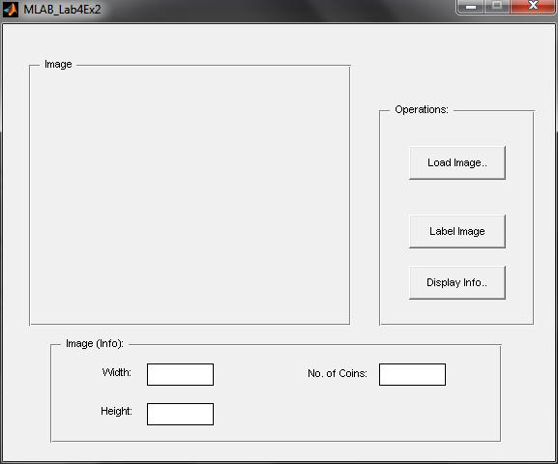

Figure 1: GUI for Exercise 1

**Screenshots:**

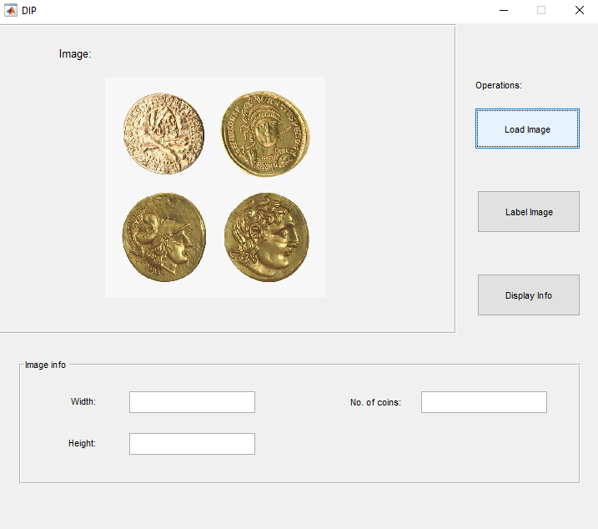

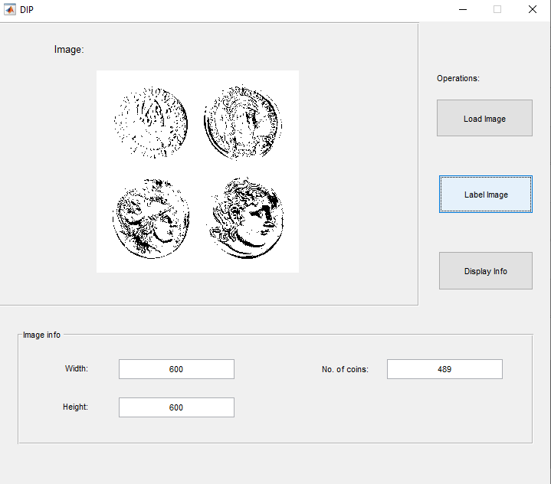

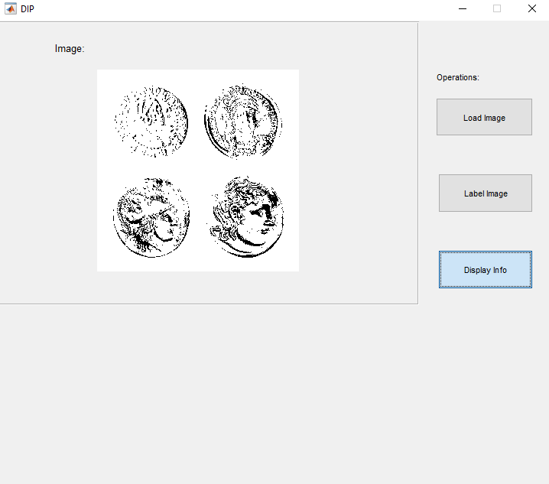

**Task 2:**

Modify the GUI you developed in Exercise 1 to incorporate the following features.

1. Load the image ‘coins.png’ (available in Matlab repository) once the user clicks the ‘Load’ button. You can directly load the image without showing the File Open Dialog to the user.
2. Clicking the ‘Label’ button, show the binarized image in the axes, find the number of components in the image and the properties of these components. A rectangle must also be drawn over each detected component (as shown in Figure 2).
3. Using the ‘Centroid’ property, join the center of the first connected component with the centers of all connected components using the ‘line’ function (Figure 3).
4. Find the area of the largest and the smallest component and display it in a text box. (Use Matlab sort function).

Figure 2: Localized connected components in the image

Figure 3: Center of first connected component joined with all other components

**Screenshots:**

